Scripted
User Manual
Written by dlsmd
Ver. 2.6

(For Scripted ver 0.99.5.24 or newer)

!!Notice!!
Do not blame me if your account gets banned.
If you agree you may continue to use Scripted.

This tool is Open-Source.
You can get the latest version here.

...Index...
- Main Window
  - File
  - Tools
    - Scripts
    - Options
  - Help
  - select process
- Farm Bot
  - Farm/Targets
  - Combat Settings
    - Options 1
    - Options 2
    - Options 3
    - Options 4
    - Options 5
    - JA's
    - MA's
    - Dynamis
  - Sambas/Steps/Waltz
    - Sambas/Steps
    - Waltz
    - Party Waltz
  - Flourishes
  - Pets
    - BST
    - DRG
    - SMN
    - PUP
    - GEO (not implemented)
  - Trust
  - In-Game HUD
- Navigation Bot
- On Event Bot
- In-Game Commands
- More info
  - Order of things
  - If the bot does not work
  - Thanks
Main Window
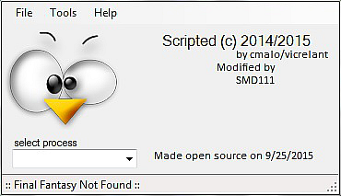
1
2
3
4
5
1: File*
2: Tools*
3: Help*
4: select process
5: Selected Process Character Name*
* All of these show in every bot and if there used is that bot check that bots main section to find out what they do

Section 1: File
Load Settings – Used in Farm Bot Only.
Save Settings – Used in Farm Bot Only.
Reset Settings – Not Used
Refresh Characters – Refreshes Character list in select process.
Close/Exit – Closes Scripted.
Section 2: Tools
Section 2.1: Scripts
Farm/DNC – Loads the Farm Bot.
Navigation – Loads the Navigation Bot.
On Event Tool – Loads the On Event Bot.
Section 2.1: Options
(currently not used)
Section 3: Help
Manual – Runs this manual.
Section 4: select process
This is ware you select the Character you want the iteration of Scripted to work on.
NOTE: If you only have one instance of FFXI running then it will auto set to that one.

Go to Index To top of Main Window section
Farm Bot
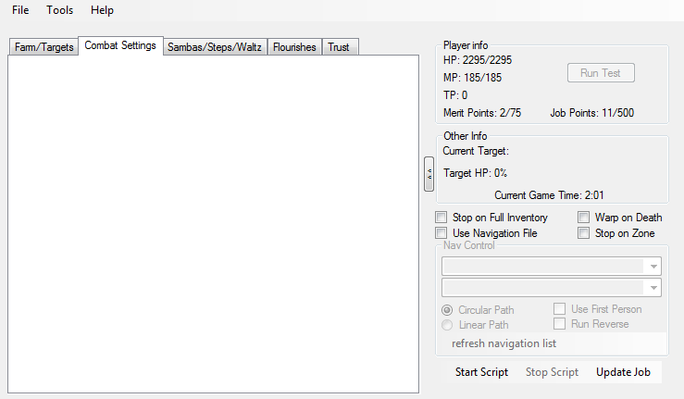
3
2
1
7
8
6
4
9
5
1: File/Tool/Help.
File.
Load Settings – Loads Farm Bot settings from a file
Save Settings – Saves Farm Bot settings to a file
Reset Settings – Not Used
Refresh Characters – Refreshes Character list in select process
Close/Exit – Closes Scripted
Tools.
Scripts.
Farm/DNC – Loads the Farm Bot
Navigation – Loads the Navigation Bot
(Note:If the Farm Bot is running a window will pop up letting you know that you need to stop the bot to use the Navigation Bot.)
On Event Tool – Loads the On Event Bot
Options.
(currently not used)

Help.
(currently not used)
2: Farm Bot tab select.
Farm/Targets, Combat Settings, Sambas/Steps/Waltz, Flourishes, Pets, Trust
(NOTE: Only the tabs needed for current job will be viable.)
3: Player Info.
HP – Current/Max HP
MP– Current/Max MP
TP – Current/Max TP
Merit Points – Current stored Merit Points
(NOTE: This will display “Cant Gain” if your Main Job is below lvl 75.)
Job Points – Current stored Job Points
(NOTE: This will display “Cant Gain” if your Main Job is below lvl 99.)
4: Run Test – When its needed to get data from multiple users I can add this to get that data.
(Note: I will post what I need in the forum.)

Go to Index To top of Farm Bot section
5: Shrink/Enlarge – Shrink's or Enlarges the Farm Bot Display.
6: Other Info.
Current target – Your current targets name.
Target HP – Your current targets HP in %.
Current Game Time – Current game time.
7: Nav file selection drop down menu.
8: Nav path control's.
Circular Path – Runs your path in a circle.
(Note: From nav point 1 to the last then from 1 to the last etc..)
Linear Path – Runs your path back and forth.
(Note: From nav point 1 to the last then the last to point 1 etc..)
9: Farm Bot Control's
Start Script – Starts the Farm Bot.
Stop Script – Stops the Farm Bot.
Update job – Resets the Farm Bot to use new job items after a job change.

(To get a sound on player death copy a file named dead.wav to scripted main directory)

Go to Index To top of Farm Bot section
Section 2.1: Farm/Targets
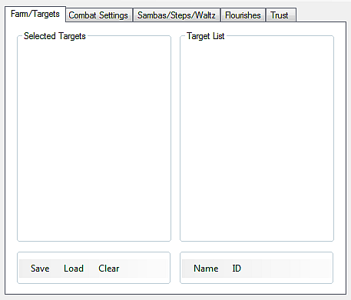
1
2
3
4
5
1: Farm Bot tab select.
Combat Settings, Sambas/Steps/Waltz, Flourishes, Pets, Trust, In-Game HUD
(NOTE: Only the tabs needed for current job will be viable.)
2: Selected Targets list.
3: Target List – All possible targets in your current zone.
4: Selected Targets Control's
Save – Save current Selected Targets list to a file.
Load – Loads saved targets list to Selected Targets list.
Clear – Clears Selected Targets list.
5: Target List Control's
Name – Populates Target List with all mob in zone based on there name.
(NOTE: If your in a none battle zone,A.K.A. Most city's, it will cause an error.)
ID – Populates Target List with all mob in zone based on there ID.
(NOTE: If your in a none battle zone,A.K.A. Most city's, it will cause an error.)

Go to Index To top of Farm Bot section
Section 2.2: Combat Settings
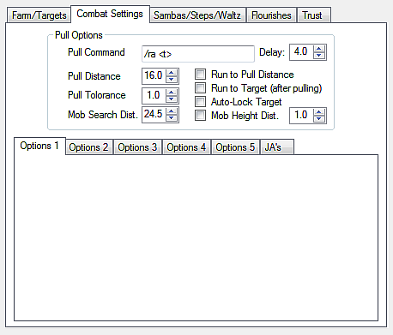
1
12
5
7
8
10
2
3
4
6
9
11
1: Farm Bot tab select.
Farm/Targets, Sambas/Steps/Waltz, Flourishes, Pets, Trust, In-Game HUD
2: Pull Command (Default: /ra <t>)
3: Pull Delay – How log it takes after you use your pull command to use it again (Default: 4.0)
4: Pull Distance – The distance from your target that you want to use the Pull Command (Default: 16.0)
(NOTE: Lower is closer to your target.)
5: Run to Pull Distance – Runs you to Pull Distance if your Mob Search Distance is higher when enabled.
6: Pull Tolerance – (currently does nothing)
7: Run To Target (after pulling) – Runs your player to your target after Pull Command.
8: Auto-Lock Target – Automatically Locks your target after Pull Command when enabled.
9: Mob Search Distance – The distance from player to search for target.
10: Mob Height Search Distance – Adds a check of height distance using Mob Height Search Distance Value to your search.
11: Mob Height Search Distance Value – The vertical distance that your target needs to be in from your player. (Default: 1.0)
12: Combat Settings tab select.
Options 1, Options 2, Options 3, Options 4, Options 5, JA's, MA's, Dynamis

Go to Index To top of Farm Bot section
Section 2.2.1: Options 1
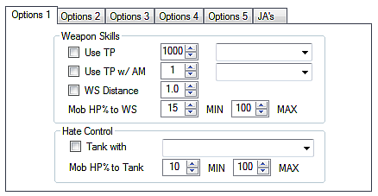
1
2
12
5
8
4
7
13
3
6
9
10
11
14
15
1: Combat Settings tab select.
Options 2, Options 3, Options 4, Options 5, JA's, MA's, Dynamis
2: Use TP – Auto-uses selected weapon skill if player TP is higher then TP Use At when enabled.
3: TP Use At – The TP to use your weapon skill at. (Default: 1000)
(The Range is 1000 - 3000)
4: Weapon Skill Drop Down Selection – List of learned weapon skills.
5: Use TP w/AM – Uses selected AM Weapon Skill.
6: AM Number – AM Number selection (Default: 1)
(The Range is 1 - 3)
7: AM Weapon Skill Drop Down Selection – List of AM weapon skills.
8: Weapon Skill Distance – Uses Weapon Skill Distance Value to use Weapon Skill when enabled.
9: Weapon Skill Distance Value – Sets Maximum Distance from target to use Weapon Skill.(Default: 1.0)
(The Range is 0.1 – 50.0)
10: Mob Hp% to Weapon Skill Minimum – Your targets minimum HP% to use weapon skills.(Default: 15)
(The Range is 0 - 100)
11: Mob Hp% to Weapon Skill Maximum – Your targets maximum HP% to use weapon skills.(Default: 100)
(The Range is 0 - 100)
12: Tank With – Uses selected Tank command if mob HP% is between Mob Hp% to Tank Min/Max.
13: Tank With Drop Down Selection – List of Tank commands based on job.
14: Mob Hp% to Tank Minimum – Current targets minimum HP% to use Tank command.(Default: 10)
(The Range is 0 - 100)
15: Mob Hp% to Tank Maximum – Current targets maximum HP% to use Tank command.(Default: 100)
(The Range is 0 - 100)

Go to Index To top of Farm Bot section
Section 2.2.2: Options 2
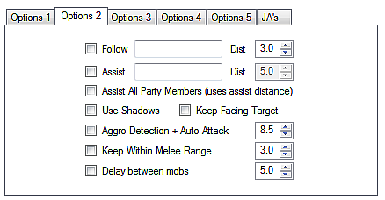
1
2
5
8
9
11
13
15
10
3
6
4
7
12
14
16
1: Combat Settings tab select.
Options 1, Options 3, Options 4, Options 5, JA's, MA's, Dynamis
2: Follow Enable – Enables Follow based on Follow Target/Distance.
3: Follow Target – The name of the Follow Target you want to follow.
4: Follow Distance – How close you want to get to your Follow Target.
(NOTE: If you can get to the set distance it will never stop trying to following your target)
(NOTE2: 0.1– You will be as close to your Follow Target as possible, 50.0 – your will never try to follow your Follow Target)
5: Target Assist Enable – Enable Assist
(NOTE: Will disable Party Assist)
6: Assist Target
(NOTE: Name of party member.)
7: Assist Search Distance – The distance you want to search for your Assist Target. (Default: 5.0)
(Range: 0.1– 50.0)
8: Party Assist Enable – Enables Party Assist
(NOTE1: Will disable Target Assist) (NOTE2: Uses Assist Search Distance)
9: Use Shadows – Enables Auto Shadow use.
10: Keep Facing Target – Keeps your player Facing your current Target.
11: Aggro Detection + Auto attack – Enables Aggro Detection + Auto attack based on Aggro Detection Distance.
12: Aggro Detection Distance – The distance from your Player that a Mob needs to be within in order to be detected.
(Default: 8.5) (Range: 0.1 – 50.0)
13: Keep Within Melee Range – Makes your Player stay within the distance set with Keep Within Melee Distance.
14: Keep Within Melee Distance – Distance used for Keep Within Melee Range. (Default: 3.0)
(Range: 0.1 – 50.0)
15: Delay between mobs – Enables After Battle delay.
16: Delay between mobs time – Time to wait after last mob for bot to continue functioning.(In Seconds) (Default: 5)

Go to Index To top of Farm Bot section
Section 2.2.3: Options 3
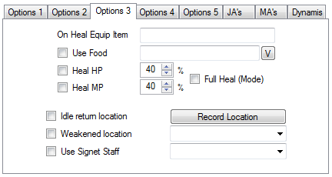
1
3
6
8
11
2
4
7
9
5
12
10
1: Combat Settings tab select.
Options 1, Options 2, Options 4, Options 5, JA's, MA's, Dynamis
2: On Heal Equip Item – When healing equips main slot with input weapon.
(NOTE: I actually recommend using Gearswap or Ashitacast to do this as I offer no support if this does not work after all your using Windower /Ashita already.)
3: Enable Use Food – Enables Auto use of Selected Food when Food buff fall off.
4: Selected Food – Name of the food you want to use.
5: Verify Food – Verifies that you have the Selected Food in your inventory.
(NOTE: This can be used to Verify any item as long as its in your Players inventory.)
6: Heal at HP% – Enables auto /heal when HP% is below Heal at HP% value
7: Heal at HP% value – Sets Hp% to auto /heal. (Default: 40)
(Range: 0 - 100)
8: Heal at MP% – Enables auto /heal when MP% is below Heal at MP% value
9: Heal at MP% value – Sets MP% to auto /heal. (Default: 40)
(Range: 0 - 100)
10: Full Heal Mode – Enables heal stand to make sure all configurable HP%/MP% are at 100% before standing.
(Default: Checked
11: Idle return location – Enables return to Idle return Record Location.
12: Idle return Record Location – Saves current x/y/z location for when idle to automatically return to.

Go to Index To top of Farm Bot section
Section 2.2.4: Options 4
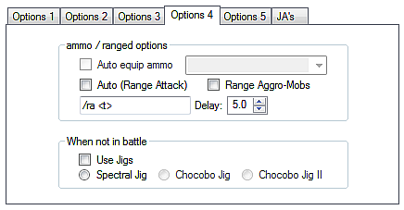
1
2
3
6
4
5
1: Combat Settings tab select.
Options 1, Options 2, Options 3, Options 5, JA's, MA's, Dynamis
2: Auto (Range Attack) – Enables automatic range skill used based on Auto Range Command and Auto Range Delay.
3: Range Aggro-Mobs –
4: Auto Range Command – The command to send after Auto Range Delay has passed. (Default: /ra <t>)
5: Auto Range Delay – The time in seconds you want to wait between sending the Auto Range Command. (Default: 5.0)
(Range: 0.1 - 50.0)
6: When not in battle
Use Jigs – Enables automatic use of Jigs outside of battle.
(NOTE: Only Spectral/Chocobo Jigs cab be set based on current job setup.)

Go to Index To top of Farm Bot section
Section 2.2.5: Options 5
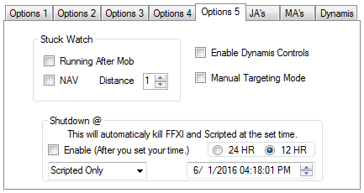
1
4
5
2
3
1: Combat Settings tab select.
Options 1, Options 2, Options 3, Options 4, JA's, MA's, Dynamis
2: Stuck Watch
Running After Mob – Enables Stuck Watch after Pulling a target.
NAV – Enables Stuck Watch while running your selected nav file.
Distance – The minimum distance your Player needs to move so Stuck Watch does not trigger. (Default: 1)
(Range: 1 - 9)
3: Enable Dynamis Controls – Enables the Dynamis tab.
4: Manual Targeting Mode – Disables Scripted's ability to change your target.
5: Shutdown
Enable – Enables Timed Automatic Shutdown.
(NOTE: Do not enable until you have set your time to shutdown.)
24/12 HR Switch – Sets hour range to 24 or 12 hour clock (Default: 12 HR)
Date/Time – Sets the date and time you want to shutdown Scripted.
Shutdown Type Selection – Sets the shutdown type.
(Selections: Scripted Only,Windowing App + Scripted) (Default:Scripted Only)

Go to Index To top of Farm Bot section
Section 2.2.6: JA's
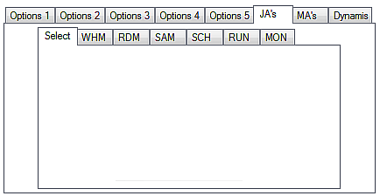
1
2
1: Combat Settings tab select.
Options 1, Options 2, Options 3, Options 4, Options 5, MA's, Dynamis
2: JA Settings tab select
Select, WHM, RDM, SAM, SCH, RUN, MON

JA'S Select
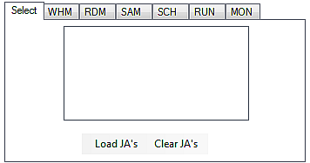
1
2
3

1: JA Settings tab select
WHM, RDM, SAM, SCH, RUN, MON
2: Player JA List.
3: Load/Clear Player JA List.
JA'S WHM
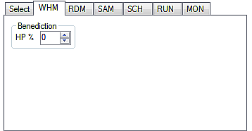
1
2

1: JA Settings tab select
Select, RDM, SAM, SCH, RUN, MON
2: Player HP% to use Benediction.
(Range: 1 - 100)

Go to Index To top of Farm Bot JA section To top of Farm Bot section
JA'S RDM
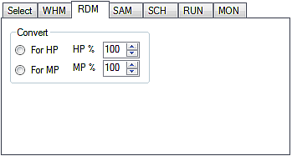
1
2
3
4

1: JA Settings tab select
Select, WHM, SAM, SCH, RUN, MON
2: Convert For HP/MP switch.
(NOTE1: If HP it checks for ( HP% to use Convert <= Player's current HP%) and ( MP% to use Convert >= Player's current MP%)
(NOTE1: If MP it checks for ( HP% to use Convert >= Player's current HP%) and ( MP% to use Convert <= Player's current MP%)
3: HP% to use Convert.
(Range: 1 - 100)
4: MP% to use Convert.
(Range: 1 - 100)

JA'S SAM
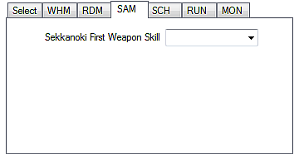
1
2

1: JA Settings tab select
Select, WHM, RDM, SCH, RUN, MON
2: First weapon skill after using Sekkanoki.

Go to Index To top of Farm Bot JA section To top of Farm Bot section
JA'S SCH
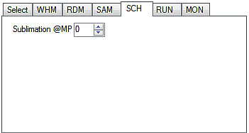
1
2

1: JA Settings tab select
Select, WHM, RDM, SAM, RUN, MON
2: Set the MP% to use Sublimation.
(Range: 1 – 100)

JA'S RUN
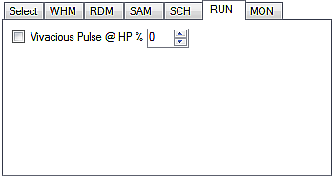
1
3
2

1: JA Settings tab select
Select, WHM, RDM, SAM, SCH, MON
2: Enable Vivacious Pulse @ HP%.
3: HP% for Vivacious Pulse.
(Range: 1 - 100)

Go to Index To top of Farm Bot JA section To top of Farm Bot section
JA'S MON
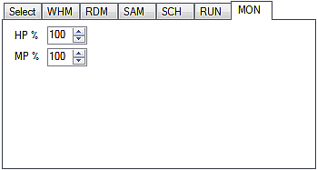
1
2
3

1: JA Settings tab select
Select, WHM, RDM, SAM, SCH, RUN
2: MON's HP% to use HP recovery skills.
(Range: 1 - 100)
3: MON's MP% to use MP recovery skills.
(Range: 1 - 100)

Go to Index To top of Farm Bot JA section To top of Farm Bot section
Section 2.2.7: MA's
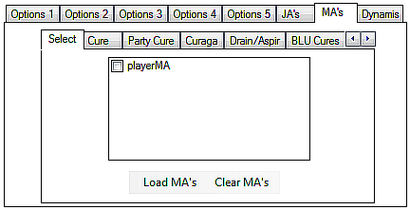
1
2
1: Combat Settings tab select.
Options 1, Options 2, Options 3, Options 4, Options 5, JA's, Dynamis
2: MA Settings tab select
Select, Cure, Party Cure, Curaga, Drain/Aspir, BLU Cures, MAconfig

MA's Select
1
2
3

1: MA Settings tab select
Cure, Party Cure, Curaga, Drain/Aspir, BLU Cures, Maconfig
2: Players Spell List.
3: Load/Clear Players Spell List.

Go to Index To top of Farm Bot MA section To top of Farm Bot section
MA's Cure
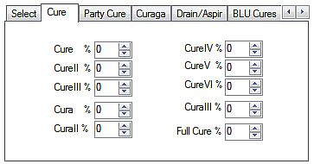
1
2
2
2
2
2
2
2
2
2
2

1: MA Settings tab select
Select, Party Cure, Curaga, Drain/Aspir, BLU Cures, Maconfig
2: Players HP% to use specified spell.
(Range: 1 - 100)

MA's Party Cure
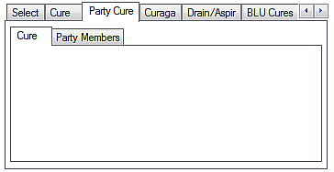
1
2

1: MA Settings tab select
Select, Cure, Curaga, Drain/Aspir, BLU Cures, Maconfig
2: MA's Party Cure tab select.

MA's Party Cure Setting
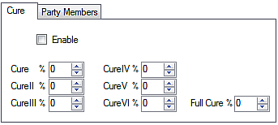
1
3
3
3
3
3
3
3
2
1: MA's Party Cure tab select.
2: Enable Party Cures.
3: Party Members HP% to use specified spell.
(Range: 1 - 100)

Go to Index To top of Farm Bot MA section To top of Farm Bot section
MA's Party Cure Party Settings
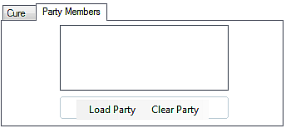
1
2
3
1: MA's Party Cure tab select.
2: Party Member List.
3: Load/Clear Party Member List.

MA's Curaga
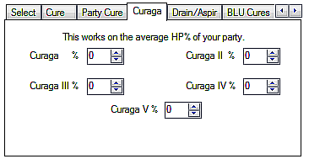
1
2
2
2
2
2

1: MA Settings tab select
Select, Cure, Party Cure, Drain/Aspir, BLU Cures, Maconfig
2: Average Party HP% to use specified Spell.
(Range: 1 - 100)

MA's Drain/Aspir
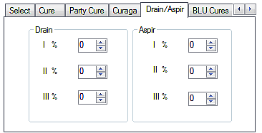
1
2
2
2
3
3
3

1: MA Settings tab select
Select, Cure, Party Cure, Curaga, BLU Cures, Maconfig
2: Player HP% to use specified Spell.
(Range: 1 - 100)
3: Player MP% to use specified Spell.
(Range: 1 - 100)

Go to Index To top of Farm Bot MA section To top of Farm Bot section
MA's BLU Cures
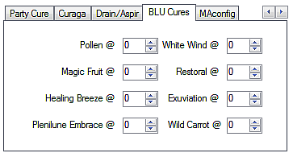
1
2
2
2
2
2
2
2
2

1: MA Settings tab select
Select, Cure, Party Cure, Curaga, Drain/Aspir, Maconfig
2: Player HP% to use specified Spell.
(Range: 1 - 100)
MA's MAconfig
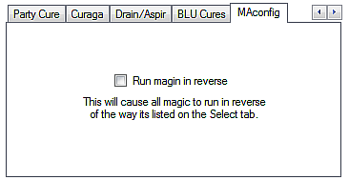
1
2

1: MA Settings tab select
Select, Cure, Party Cure, Curaga, Drain/Aspir, BLU Cures
2: Run Spells in reverse order from the way they show in in the select list.

Go to Index To top of Farm Bot MA section To top of Farm Bot section
Section 2.2.8: Dynamis
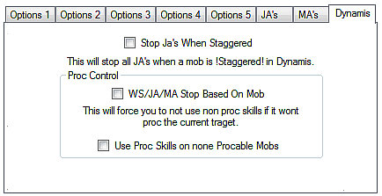
1
4
3
2
1: Combat Settings tab select.
Options 1, Options 2, Options 3, Options 4, Options 5, JA's, MA's
2: Stop Ja's When Staggered – Stops all JA's when current target is staggered when enabled.
3: WS/JA/MA Stop Based On Mob – Stops skills based on if your current target can be proc'd by the specific skill type.
(Note: When this is disabled Scripted will use all selected skills on all mobs that can be proc'd)
4: Use Proc Skills on none Procable Mobs – Allows you all attacks on Dynamis mobs that can never be proc'd.
(Note: When this is disabled you will not use ability's that target a mob when your current target is on none procable mobs.)

Go to Index To top of Farm Bot section
Section 2.3: Sambas/Steps/Waltz
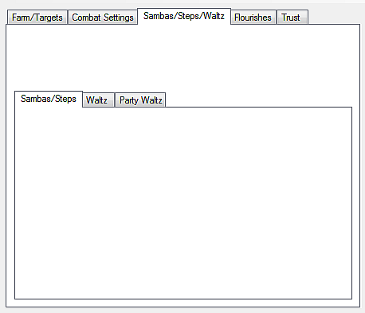
1
2
1: Farm Bot tab select.
Farm/Targets, Combat Settings, Flourishes, Pets, Trust, In-Game HUD
2: Sambas/Steps tab select.
Sambas/Steps, Waltz, Party Waltz

Go to Index To top of Farm Bot section
Section 2.3.1: Sambas/Steps
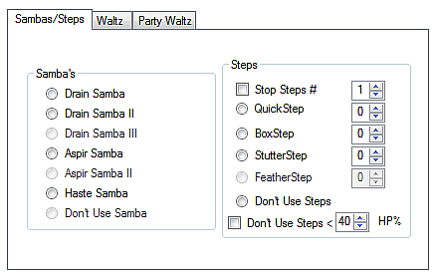
1
2
5
3
6
7
4
8
1: Sambas/Steps tab select.
Waltz, Party Waltz
2: Samba selection list.
3: Stop Steps enable – Enables Stop Steps.
4: Stop Steps Value – Sets the max Steps for Stop Steps.
(Range: 1 – 6) (NOTE: Because it impossible to count more the 6 steps reliably the max is 6.)
5: Step selection.
6: Don't Use Steps – Turns off Steps on the fly.
7: Don't Use Steps < HP% – Stops steps if your Player is below Stop Steps HP%.
8: Stop Steps HP% – Player HP% for Don't Use Steps < HP%.

Go to Index To top of Farm Bot - Waltz section
Section 2.3.2: Waltz
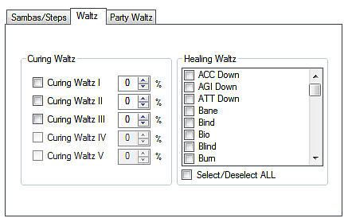
1
4
5
2
3
3
3
3
3
1: Sambas/Steps tab select.
Sambas/Steps, Party Waltz
2: Waltz Enable Selection – Enables each individual Waltz based on appropriate Waltz Below Player HP%.
3: Waltz Below Player HP% – Sets HP% for each individual Waltz.
(Range: 1 - 100)
4: Healing Waltz deBuff selection box – A list of every deBuff that Healing Waltz can remove.
5: Select/Deselect ALL – Selects/Deselects all buffs from Healing Waltz deBuff selection box.

Go to Index To top of Farm Bot - Waltz section
Section 2.3.3: Party Waltz
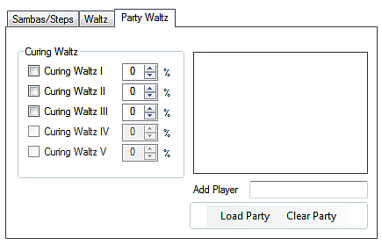
1
4
2
3
3
3
3
3
5
1: Sambas/Steps tab select.
Sambas/Steps, Waltz
2: Party Waltz Enable Selection – Enables each individual Waltz based on appropriate Party Waltz Below Members HP%.
3: Party Waltz Below Members HP% – Sets HP% for each individual Waltz.
(Range: 1 - 100)
4: Party Waltz Member list – List of current Party Members after you Load Party.
5: Party Waltz Member list Control's
Load Party – Adds all current party members to Party Waltz Member list.
Clear Party – Clears Party Waltz Member list.

Go to Index To top of Farm Bot - Waltz section
Section 2.4: Flourishes
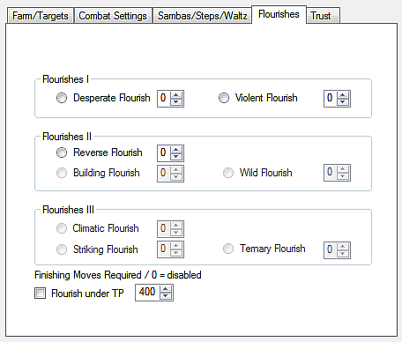
1
3
2
2
2
2
2
2
2
2
2
4
1: Farm Bot tab select.
Farm/Targets, Combat Settings, Sambas/Steps/Waltz, Pets, Trust, In-Game HUD
2: Finishing Move For Use – How many finishing moves you want to build before you use the specific flourish.
(NOTE: 0 will disable, 7 will always use it no mater how many finishing moves you have as long as its not on recast)
3: Flourish under TP – Enables using flourishes only under Flourish under TP value.
4: Flourish under TP value – The max TP you want to use Flourishes.

Go to Index To top of Farm Bot section
Section 2.5: Pets
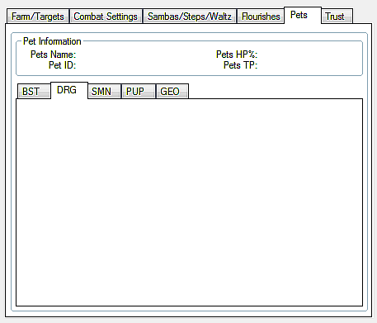
1
3
2
1: Farm Bot tab select.
Farm/Targets, Combat Settings, Sambas/Steps/Waltz, Flourishes, Trust, In-Game HUD
2: Pet Information
Pets Name – Current Pets Name.*
Pet ID – Current Pets zone ID.*
Pets HP% – Current Pets HP%.*
Pets TP – Current Pets TP.*
*Will be empty if Player has no pet.
3: Pet tab select.
BST, DRG, SMN, PUP, GEO

Go to Index To top of Farm Bot section
Section 2.5.1: BST
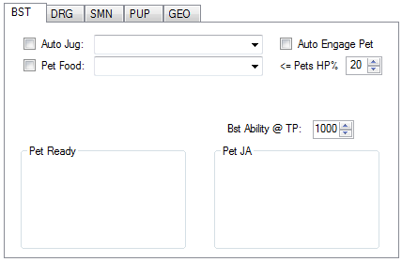
1
2
4
5
9
10
3
6
7
8
1: Pet tab select.
DRG, SMN, PUP, GEO
2: Auto Jug – Enables Auto Jug use with selected Jug from Auto Jug Select Drop Down.
3: Auto Jug Select Drop Down – A list of all Jugs to be used with Auto Jug.
4: Auto Engage Pet – Auto engages your current pet when you go in to battle.
5: Auto Use Pet Food – Auto uses selected pet food if your current pets HP% is below Auto Use Pet Food HP%.
6: Auto Use Pet Food Select Drop Down – Select the pet food you want to use with Auto Use Pet Food.
7: Auto Use Pet Food HP% – Set the pet HP% your pet needs to be below to auto use food. (Default: 20)
(Range: 0 - 100)
8: Bst Ability @ TP –Sets the TP to use Bst Ability's.
9: Pet Ready Commands – A list of Ready commands based on currently selected Auto Jug.
10: Pet JA's – A list of BST Ability's used only when you have a pet.

Go to Index To top of Farm Bot section
Section 2.5.2: DRG
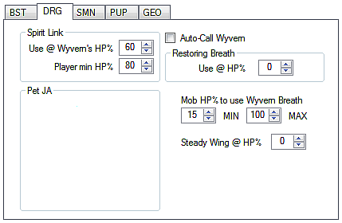
1
2
6
3
4
5
7
8
9
1: Pet tab select.
BST, SMN, PUP, GEO
2: Auto Call Wyvern – Will automatically call your Wyvern if it dies or is not out yet.
3: Spirit Link Use Wyvern HP% – Sets the maximum Wyvern HP% to use Spirit Link.
(Range: 0 - 100)
4: Spirit Link Use Player HP% – Sets the minimum Player HP% to use Spirit Link.
(Range: 0 - 100)
5: Restoring Breath Use at Player HP% – Sets the maximum Player HP% to use Restoring Breath.
(Range: 0 - 100)
6: Pet JA's – A list of DRG Ability's used only when you have your Wyvern out.
7: Minimum Mob HP% to use Wyvern Breath – Sets the minimum HP% of your Target to use Steady Wing.
(Range: 0 - 100)
8: Maximum Mob HP% to use Wyvern Breath – Sets the maximum HP% of your Target to use Steady Wing.
(Range: 0 - 100)
9: Use Steady Wing at HP% – Sets the maximum Wyvern HP% to use Steady Wing.
(Range: 0 - 100)

Go to Index To top of Farm Bot section
Section 2.5.3: SMN
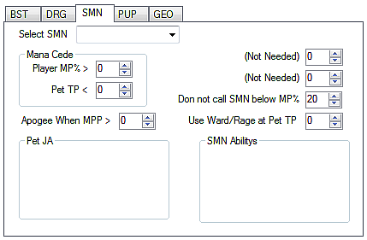
1
10
11
2
3
4
5
6
7
9
8
1: Pet tab select.
BST, DRG, PUP, GEO
2: Select Summon Drop Down list – A list of the Summon spell you can cast based on which ones you have learned.
3: Mana Cede Player MP% – Sets minimum Player MP% to use Mana Cede.
(Range: 0 - 100)
4: Mana Cede Pet TP – Sets maximum Pet TP to use Mana Cede.
5: Summon Pet Healing Skill 1 – Automatically changed skill based on the Summon you select.
(NOTE: Sets the Maximum HP% to use specified skill.)(Range: 0 - 100)
6: Summon Pet Healing Skill 2 – Automatically changed skill based on the Summon you select.
(NOTE: Sets the Maximum HP% to use specified skill.)(Range: 0 - 100)
7: Do not cast Summon below MP% – Sets the minimum Player MP% to allow calling a Summon Pet. (Default: 20)
(Range: 0 - 100)
8: Apogee When MP% – Sets the maximum Player MP% to allow the use of Apogee.
(Range: 0 - 100)
9: Use Ward/Rage Pet Skill at Pets TP – (Currently does nothing)
(Range: 0 - 100)
10: Pet JA's – A list of SMN Ability's used only when you have a Summon out.
11: Summon Pet Ability's – A list of all Pet commands based on Selected Summon.

Go to Index To top of Farm Bot section
Section 2.5.4: PUP
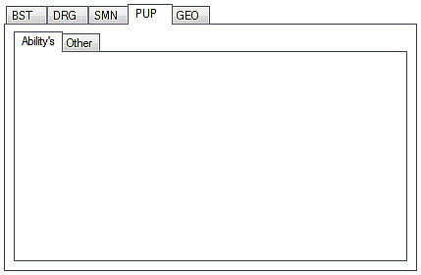
1
2
1: Pet tab select.
BST, DRG, SMN, GEO
2: Pet tab select.
Ability's, Other

PUP Ability's
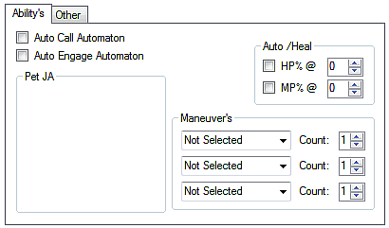
1
2
3
4
6
8
9
5
7
1: Pet tab select.
Other
2: Auto Call Automaton – Activates your Automaton if its not out.
3: Auto Engage Automaton – Automatically engages your Automaton when you go in to battle.
4: Auto /heal for Automaton HP – Enables /heal check for Automaton when Pet HP% below setting.
5: Auto /heal for Automaton when HP% below – Sets Automaton /heal check HP% setting.
(Range: 0 - 100)
6: Auto /heal for Automaton MP – Enables /heal check for Automaton when Pet MP% below setting.
7: Auto /heal for Automaton when MP% below – Sets Automaton /heal check MP% setting.
(Range: 0 - 100)
8: Pet JA's – A list of PUP Ability's used only when you have your Automaton out.
9: Maneuver's
Selection Box Drop Down – A complete list of Maneuver's to select from.
Count – How many of the selected Maneuver's you want to have up.
(Range: 1 – 3) (Limit of 3 Maneuver's even if they are all the same unless you want them to cycle continually.)

Go to Index To top of Farm Bot section
PUP Other
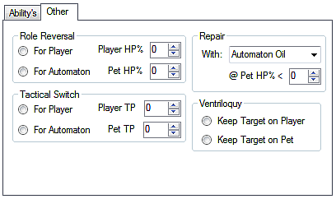
1
10
2
7
3
4
8
9
6
5
1: Pet tab select.
Ability's
2: Role Reversal For Player/Automaton Switch – Sets-up Role Reversal for Player or Automaton.
(NOTE1: If Player it checks for (Role Reversal Player HP% >= Player's current HP%) and (Role Reversal Automaton HP% <= Pet's current HP%)
(NOTE1: If Automaton it checks for (Role Reversal Player HP% <= Player's current HP%) and (Role Reversal Automaton HP% >= Pet's current HP%)
3: Role Reversal Player HP% – Sets Player HP% for Role Reversal.
(Range: 0 - 100)
4: Role Reversal Automaton HP% – Sets Automaton HP% for Role Reversal.
(Range: 0 - 100)
5: Select the Repair Oil you want to use with Repair
6: Use Repair Oil at Automaton HP% – Sets maximum Pet HP% to use Repair.
(Range: 0 - 100)
7: Tactical Switch For Player/Automaton Switch – Sets-up Tactical Switch for Player or Automaton.
(NOTE1: If Player it checks for (Tactical Switch Player TP >= Player's current TP) and (Tactical Switch Automaton TP <= Pet's current TP)
(NOTE1: If Automaton it checks for (Tactical Switch Player TP <= Player's current TP) and (Tactical Switch Automaton TP >= Pet's current TP)
8: Tactical Switch Player TP – Sets Player TP for Tactical Switch.
(Range: 0 - 3000)
9: Tactical Switch Automaton TP – Sets Automaton TP for Tactical Switch.
(Range: 0 - 3000)
10: Ventriloquy For Player/Automaton Switch – Sets-up Ventriloquy for Player or Automaton.
(NOTE: Only works if current Target is actively Targeting Player or Automaton.)

Section 2.5.5: GEO (not implemented)

Go to Index To top of Farm Bot - Pets section
Section 2.6: Trust
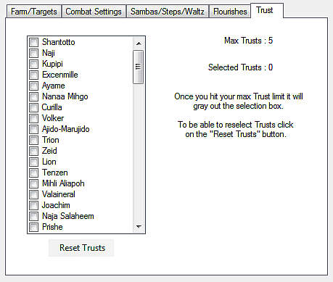
1
3
4
2
5
1: Farm Bot tab select.
Farm/Targets, Combat Settings, Sambas/Steps/Waltz, Flourishes, Pets, In-Game HUD
2: Trust list checkbox. – A checklist of every Trust you can use.
3: Max Trusts. – The max number of Trusts you can use.
4: Selected Trusts. – The number of Trusts you have selected in the Trust list checkbox.
5: Reset Trusts – Resets all Trusts settings.

Go to Index To top of Farm Bot section
Section 2.7: In-Game HUD
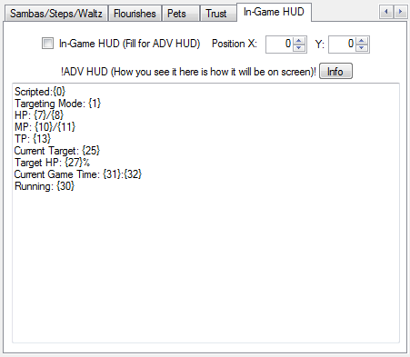
5
2
6
3
4
1
1: Farm Bot tab select.
Farm/Targets, Combat Settings, Sambas/Steps/Waltz, Flourishes, Pets
2: Enable In-Game HUD.
3: Set X POS of HUD.
4: Set Y POS of HUD.
5: Open info window.
6: ADV HUD display builder.
(NOTE: Disable HUD when changing these.)
Go to Index
Navigation Bot
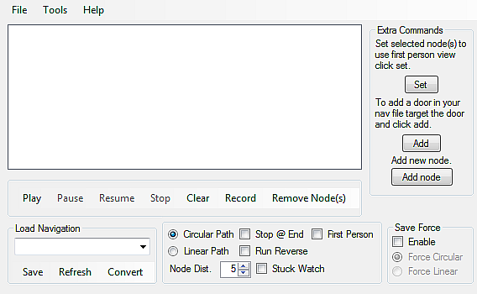
9
10
11
13
5
7
14
8
1
6
Navigation Node List
2
3
4
12
1: File/Tools/Help
File
Load Settings – Used in Farm Bot Only
Save Settings – Used in Farm Bot Only
Reset Settings – Not Used
Refresh Characters – Refreshes Character list in select process
Close/Exit – Closes Scripted
Tools
Scripts
Farm/DNC – Loads the Farm Bot
(Note:If the Navigation Bot is running a window will pop up letting you know that you need to stop the bot to use the Farm Bot.)
Navigation – Loads the Navigation Bot
On Event Tool – Loads the On Event Bot
Options
(currently not used)
Help
(currently not used)
2: Sets selected nodes in Navigation Node List to use First person view.
3: Adds the automatic Door command to the last slot in Navigation Node List.
(NOTE: To use this its best to target the door and put your nose right on it then click this.)
4: Force Adds a new node at the end of the Navigation Node List.
5: Navigation Bot main control's
Play – Run Loaded Navigation File.
Pause – Pauses Running Navigation File.
Resume – Resumes Paused Navigation File.
Stop – Stops Running Navigation File.
Clear – Clears Navigation Node List.
Record – Start Recording Navigation Nodes.
Remove Node(s) – Removes Selected Nodes in Navigation Node List.
6: Load Navigation Drop Down selection – A List of all Navigation files in your Scripted Nav folder.

Go to Index To top of Navigation Bot section
7: Load Navigation file control's
Save – Saves current Navigation Node List to a file.
Refresh – Refreshes Load Navigation Drop Down list.
Convert – Converts XiClaim navigation to Scripted Navigation file.
8: Circular/Linear Path type switch – Sets Navigation path type to Circular or Linear.
(NOTE Circular: From navigation point 1 to the last then from 1 to the last etc..) (NOTE Linear: From navigation point 1 to the last then the last to point 1 etc..)
9: Stop Running Navigation at End of file – Stops the Navigation Bot when you reach the end of your file.
(NOTE: If running navigation file in reverse it will stop at the first node.)
10: Run Navigation in First Person view – Sets your Player to be in First Person view While running a Navigation File.
11: Run Navigation File in Reverse – Runs your loaded Navigation File from the last node to the first.
12: Node Distance – The distance your Player needs to move to automatically add node's to the Navigation Node List.
(Default: 5) (Range: 1 - 10)
13: Enables Stuck Watch
14: Save Force Circular/Linear Path type switch
Forces both the Farm/Navigation Bots to setup path type on loading the Navigation File.

Go to Index To top of Navigation Bot section
On Event Bot
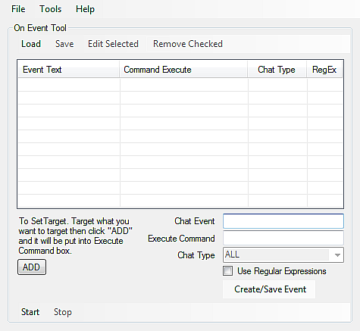
7
Event List
1
2
9
4
5
6
8
3
1: File/Tools/Help
File
Load Settings – Used in Farm Bot Only
Save Settings – Used in Farm Bot Only
Reset Settings – Not Used
Refresh Characters – Refreshes Character list in select process
Close/Exit – Closes Scripted
Tools
Scripts
Farm/DNC – Loads the Farm Bot
Navigation – Loads the Navigation Bot
On Event Tool – Loads the On Event Bot
Options
(currently not used)
Help
(currently not used)
2: Even List Control's
Load – Loads saved Event List.
Save – Saves current event List.
Edit Selected – Allows you to edit the currently selected Even in the Event List.
(NOTE: If more then one is selected it will cause an error.)
Remove Checked – Removes all checked events I the Event List/
3: Adds current Target to Execute Command.
4: Chat Event – The chat string you want to watch for.
5: Execute Command – The command you want to trigger when the chat line from Chat Event is seen.
6: Chat Type Drop Down – (currently does nothing)

Go to Index To top of On Event Bot section
7: Enables the use of REGEX Chat searches.
8: Adds Built Event to the Event List.
9: On Event main Control's
Start – Starts the On Event Bot.
Stop – Stops the On Event Bot.

Go to Index To top of On Event Bot section
In-Game Commands
(all command are not case sensitive)

To use the in-game commands:
in Windower and Ashita: “//scripted <command> <subcommands>”

Commands:
start – Starts the bot.
stop – Stops the bot.
toggle –
farmbot – Toggles on and off the farm bot.
eventbot – Toggles on and off the on-event bot.
hud – Toggles the In-Game HUD on and off.
set –
hudxy <x> <y> – sets the pos of the In-Game HUD.

Go to Index To top of In-Game Commands section
More info
Section 1: Order of things (the order that the bot works)
- Farm Bot
Main Thread.
Zone Change Check.
Player Death Check.
Follow.
Assist.
Aggro Check.
Find Next Target.
Attack New Target.
Keep Within Melee Range.
Use NIN Shadows.
Hate Control.
Use Waltz Self.
Use Waltz Party.
Use Samba.
Use Steps.
Auto Range.
Use Food.
Use Player JA's.
Use Player WS's.
Use Player MA's.
Use Flourish.
End Battle.
Delay between mobs.
Return To Idle Location.
/heal Check.
When not /healing.
Use Trusts.
Use Jig's.
Trigger Nav Start.
While /healing.
Watch for HP%/MP% to reach 100%.
End /heal.
Start Over
Pet Thread.
While in Battle Only.
Pet JA's.
Pet Commands.
Start Over.

Section 2: If the bot does not work
- Check this manual to make sure your using it correctly.
- Make sure that you have all necessary files and that you have fully updated.
- Run the test tool to verify that all API's are installed. You can go HERE for more info.
- After the above then ask questions on the forum. HERE.
- If you get an error in Windower/Ashita on the farm bots load saying that ScriptedExtender can not be found copy the ScriptedExtender folder to your addon folder.
(If your using windower: <WindowerFolder>\addons)
(If Ashita: <WindowerFolder>\Scripts\Addons)

Section 3: Thanks
Wiccan/Atom0s for making the EliteAPI without it this bot would not work at all.

Original writer of the bot Vicrelant/Cmalo and thanks for making it open source.

Those testers who test non-release versions.

Anyone else who I forgot to mention.

Go to Index
Section 4: Dynamis Proc info
(Time of Day/Skill Type/Mob Name)
Morning (00:00-07:59)
JA
Kindred Thief, Kindred Beastmaster, Kindred Monk, Kindred Ninja, Kindred Ranger, Duke Gomory,
Marquis Andras, Marquis Gamygyn, Count Raum, Marquis Cimeries, Marquis Caim, Baron Avnas, Hydra Thief, Hydra Beastmaster, Hydra Monk, Hydra Ninja, Hydra Ranger, Vanguard Backstabber, Vanguard Grappler, Vanguard Hawker, Vanguard Pillager, Vanguard Predator, Voidstreaker Butchnotch, Steelshank Kratzvatz, Vanguard Beasttender, Vanguard Kusa, Vanguard Mason, Vanguard Militant, Vanguard Purloiner,
Ko'Dho Cannonball, Vanguard Assassin, Vanguard Liberator, Vanguard Ogresoother, Vanguard Salvager,
Vanguard Sentinel, Wuu Qoho the Razorclaw, Tee Zaksa the Ceaseless, Vanguard Ambusher, Vanguard Hitman, Vanguard Pathfinder, Vanguard Pit, Vanguard Welldigger, Bandrix Rockjaw, Lurklox Dhalmelneck,
Trailblix Goatmug, Kikklix Longlegs, Snypestix Eaglebeak, Jabkix Pigeonpecs, Blazox Boneybod,
Bootrix Jaggedelbow, Mobpix Mucousmouth, Prowlox Barrelbelly, Slystix Megapeepers, Feralox Honeylips, Bordox Kittyback, Droprix Granitepalms, Routsix Rubbertendon, Slinkix Trufflesniff, Swypestix Tigershins, Nightmare Crawler, Nightmare Raven, Nightmare Uragnite, Nightmare Fly, Nightmare Flytrap,
Nightmare Funguar, Nightmare Gaylas, Nightmare Kraken, Nightmare Roc, Nightmare Hornet, Nightmare Bugard, Woodnix Shrillwhistle, Hamfist Gukhbuk, Lyncean Juwgneg, Va'Rhu Bodysnatcher, Doo Peku the Fleetfoot, Nant'ina, Antaeus

MA
Kindred White Mage, Kindred Bard, Kindred Summoner, Kindred Black Mage, Kindred Red Mage, Duke Berith, Marquis Decarabia, Prince Seere, Marquis Orias, Marquis Nebiros, Duke Haures, Hydra White Mage, Hydra Bard, Hydra Summoner, Hydra Black Mage, Hydra Red Mage, Vanguard Amputator, Vanguard Bugler,
Vanguard Dollmaster, Vanguard Mesmerizer, Vanguard Vexer, Soulsender Fugbrag, Reapertongue Gadgquok, Battlechoir Gitchfotch, Vanguard Constable, Vanguard Minstrel, Vanguard Protector, Vanguard Thaumaturge, Vanguard Undertaker, Gi'Pha Manameister, Gu'Nhi Noondozer, Ra'Gho Darkfount, Va'Zhe Pummelsong,
Vanguard Chanter, Vanguard Oracle, Vanguard Prelate, Vanguard Priest, Vanguard Visionary,
Loo Hepe the Eyepiercer, Xoo Kaza the Solemn, Haa Pevi the Stentorian, Xuu Bhoqa the Enigma,
Fuu Tzapo the Blessed, Naa Yixo the Stillrage, Vanguard Alchemist, Vanguard Enchanter, Vanguard Maestro, Vanguard Necromancer, Vanguard Shaman, Elixmix Hooknose, Gabblox Magpietongue, Hermitrix Toothrot, Humnox Drumbelly, Morgmox Moldnoggin, Mortilox Wartpaws, Distilix Stickytoes, Jabbrox Grannyguise, Quicktrix Hexhands, Wilywox Tenderpalm, Ascetox Ratgums, Brewnix Bittypupils, Gibberox Pimplebeak, Morblox Stubthumbs, Whistrix Toadthroat, Nightmare Bunny, Nightmare Eft, Nightmare Mandragora,
Nightmare Hippogryph, Nightmare Sabotender, Nightmare Sheep, Nightmare Snoll, Nightmare Stirge,
Nightmare Weapon, Nightmare Makara, Nightmare Cluster, Gosspix Blabblerlips, Flamecaller Zoeqdoq,
Gi'Bhe Fleshfeaster, Ree Nata the Melomanic, Baa Dava the Bibliophage, Aitvaras

WS
Kindred Paladin, Kindred Warrior, Kindred Samurai, Kindred Dragoon, Kindred Dark Knight, Count Zaebos,
Duke Scox, Marquis Sabnak, King Zagan, Count Haagenti, Hydra Paladin, Hydra Warrior, Hydra Samurai,
Hydra Dragoon, Hydra Dark Knight, Vanguard Footsoldier, Vanguard Gutslasher, Vanguard Impaler,
Vanguard Neckchopper, Vanguard Trooper, Wyrmgnasher Bjakdek, Bladerunner Rokgevok, Bloodfist Voshgrosh, Spellspear Djokvukk, Vanguard Defender, Vanguard Drakekeeper, Vanguard Hatamoto, Vanguard Vigilante, Vanguard Vindicator, Ze'Vho Fallsplitter, Zo'Pha Forgesoul, Bu'Bho Truesteel, Vanguard Exemplar,
Vanguard Inciter, Vanguard Partisan, Vanguard Persecutor, Vanguard Skirmisher, Maa Febi the Steadfast,
Muu Febi the Steadfast, Vanguard Armorer, Vanguard Dragontamer, Vanguard Ronin, Vanguard Smithy,
Buffrix Eargone, Cloktix Longnail, Sparkspox Sweatbrow, Ticktox Beadyeyes, Tufflix Loglimbs,
Wyrmwix Snakespecs, Karashix Swollenskull, Smeltix Thickhide, Wasabix Callusdigit, Anvilix Sootwrists, Scruffix Shaggychest, Tymexox Ninefingers, Scourquix Scaleskin, Draklix Scalecrust, Moltenox Stubthumbs, Ruffbix Jumbolobes, Shisox Widebrow, Tocktix Thinlids, Nightmare Crab, Nightmare Dhalmel,
Nightmare Scorpion, Nightmare Goobbue, Nightmare Manticore, Nightmare Treant, Nightmare Diremite, Nightmare Tiger, Nightmare Raptor, Nightmare Leech, Nightmare Worm, Shamblix Rottenheart,
Elvaansticker Bxafraff, Qu'Pho Bloodspiller, Te'Zha Ironclad, Koo Rahi the Levinblade, Barong,
Alklha, Stihi, Fairy Ring, Stcemqestcint, Stringes, Suttung

Go to Index
Noon (8:00-15:59)
JA
Kindred Thief, Kindred Beastmaster, Kindred Monk, Kindred Ninja, Kindred Ranger, Duke Gomory,
Marquis Andras, Marquis Gamygyn, Count Raum, Marquis Cimeries, Marquis Caim, Baron Avnas, Hydra Thief, Hydra Beastmaster, Hydra Monk, Hydra Ninja, Hydra Ranger, Vanguard Backstabber, Vanguard Grappler, Vanguard Hawker, Vanguard Pillager, Vanguard Predator, Voidstreaker Butchnotch, Steelshank Kratzvatz, Vanguard Beasttender, Vanguard Kusa, Vanguard Mason, Vanguard Militant, Vanguard Purloiner,
Ko'Dho Cannonball, Vanguard Assassin, Vanguard Liberator, Vanguard Ogresoother, Vanguard Salvager,
Vanguard Sentinel, Wuu Qoho the Razorclaw, Tee Zaksa the Ceaseless, Vanguard Ambusher, Vanguard Hitman, Vanguard Pathfinder, Vanguard Pit, Vanguard Welldigger, Bandrix Rockjaw, Lurklox Dhalmelneck,
Trailblix Goatmug, Kikklix Longlegs, Snypestix Eaglebeak, Jabkix Pigeonpecs, Blazox Boneybod,
Bootrix Jaggedelbow, Mobpix Mucousmouth, Prowlox Barrelbelly, Slystix Megapeepers, Feralox Honeylips, Bordox Kittyback, Droprix Granitepalms, Routsix Rubbertendon, Slinkix Trufflesniff, Swypestix Tigershins, Nightmare Bunny, Nightmare Eft, Nightmare Mandragora, Nightmare Hippogryph, Nightmare Sabotender, Nightmare Sheep, Nightmare Snoll, Nightmare Stirge, Nightmare Weapon, Nightmare Makara, Nightmare Cluster, Woodnix Shrillwhistle, Hamfist Gukhbuk, Lyncean Juwgneg, Va'Rhu Bodysnatcher, Doo Peku the Fleetfoot, Nant'ina, Antaeus

MA
Kindred White Mage, Kindred Bard, Kindred Summoner, Kindred Black Mage, Kindred Red Mage, Duke Berith, Marquis Decarabia, Prince Seere, Marquis Orias, Marquis Nebiros, Duke Haures, Hydra White Mage, Hydra Bard, Hydra Summoner, Hydra Black Mage, Hydra Red Mage, Vanguard Amputator, Vanguard Bugler,
Vanguard Dollmaster, Vanguard Mesmerizer, Vanguard Vexer, Soulsender Fugbrag, Reapertongue Gadgquok, Battlechoir Gitchfotch, Vanguard Constable, Vanguard Minstrel, Vanguard Protector, Vanguard Thaumaturge, Vanguard Undertaker, Gi'Pha Manameister, Gu'Nhi Noondozer, Ra'Gho Darkfount, Va'Zhe Pummelsong,
Vanguard Chanter, Vanguard Oracle, Vanguard Prelate, Vanguard Priest, Vanguard Visionary,
Loo Hepe the Eyepiercer, Xoo Kaza the Solemn, Haa Pevi the Stentorian, Xuu Bhoqa the Enigma,
Fuu Tzapo the Blessed, Naa Yixo the Stillrage, Vanguard Alchemist, Vanguard Enchanter, Vanguard Maestro, Vanguard Necromancer, Vanguard Shaman, Elixmix Hooknose, Gabblox Magpietongue, Hermitrix Toothrot, Humnox Drumbelly, Morgmox Moldnoggin, Mortilox Wartpaws, Distilix Stickytoes, Jabbrox Grannyguise, Quicktrix Hexhands, Wilywox Tenderpalm, Ascetox Ratgums, Brewnix Bittypupils, Gibberox Pimplebeak, Morblox Stubthumbs, Whistrix Toadthroat, Nightmare Crab, Nightmare Dhalmel, Nightmare Scorpion,
Nightmare Goobbue, Nightmare Manticore, Nightmare Treant, Nightmare Diremite, Nightmare Tiger,
Nightmare Raptor, Nightmare Leech, Nightmare Worm ,Gosspix Blabblerlips, Flamecaller Zoeqdoq,
Gi'Bhe Fleshfeaster, Ree Nata the Melomanic, Baa Dava the Bibliophage, Aitvaras

WS
Kindred Paladin, Kindred Warrior, Kindred Samurai, Kindred Dragoon, Kindred Dark Knight, Count Zaebos,
Duke Scox, Marquis Sabnak, King Zagan, Count Haagenti, Hydra Paladin, Hydra Warrior, Hydra Samurai,
Hydra Dragoon, Hydra Dark Knight, Vanguard Footsoldier, Vanguard Gutslasher, Vanguard Impaler,
Vanguard Neckchopper, Vanguard Trooper, Wyrmgnasher Bjakdek, Bladerunner Rokgevok, Bloodfist Voshgrosh, Spellspear Djokvukk, Vanguard Defender, Vanguard Drakekeeper, Vanguard Hatamoto, Vanguard Vigilante, Vanguard Vindicator, Ze'Vho Fallsplitter, Zo'Pha Forgesoul, Bu'Bho Truesteel, Vanguard Exemplar,
Vanguard Inciter, Vanguard Partisan, Vanguard Persecutor, Vanguard Skirmisher, Maa Febi the Steadfast,
Muu Febi the Steadfast, Vanguard Armorer, Vanguard Dragontamer, Vanguard Ronin, Vanguard Smithy,
Buffrix Eargone, Cloktix Longnail, Sparkspox Sweatbrow, Ticktox Beadyeyes, Tufflix Loglimbs,
Wyrmwix Snakespecs, Karashix Swollenskull, Smeltix Thickhide, Wasabix Callusdigit, Anvilix Sootwrists, Scruffix Shaggychest, Tymexox Ninefingers, Scourquix Scaleskin, Draklix Scalecrust, Moltenox Stubthumbs, Ruffbix Jumbolobes, Shisox Widebrow, Tocktix Thinlids, Nightmare Crawler, Nightmare Raven,
Nightmare Uragnite, Nightmare Fly, Nightmare Flytrap, Nightmare Funguar, Nightmare Gaylas,
Nightmare Kraken, Nightmare Roc, Nightmare Hornet, Nightmare Bugard, Shamblix Rottenheart,
Elvaansticker Bxafraff, Qu'Pho Bloodspiller, Te'Zha Ironclad, Koo Rahi the Levinblade, Barong, Alklha,
Stihi, Fairy Ring, Stcemqestcint, Stringes, Suttung

Go to Index
Night (16:00-23:59)
JA
Kindred Thief, Kindred Beastmaster, Kindred Monk, Kindred Ninja, Kindred Ranger, Duke Gomory,
Marquis Andras, Marquis Gamygyn, Count Raum, Marquis Cimeries, Marquis Caim, Baron Avnas, Hydra Thief, Hydra Beastmaster, Hydra Monk, Hydra Ninja, Hydra Ranger, Vanguard Backstabber, Vanguard Grappler, Vanguard Hawker, Vanguard Pillager, Vanguard Predator, Voidstreaker Butchnotch, Steelshank Kratzvatz, Vanguard Beasttender, Vanguard Kusa, Vanguard Mason, Vanguard Militant, Vanguard Purloiner,
Ko'Dho Cannonball, Vanguard Assassin, Vanguard Liberator, Vanguard Ogresoother, Vanguard Salvager,
Vanguard Sentinel, Wuu Qoho the Razorclaw, Tee Zaksa the Ceaseless, Vanguard Ambusher, Vanguard Hitman, Vanguard Pathfinder, Vanguard Pit, Vanguard Welldigger, Bandrix Rockjaw, Lurklox Dhalmelneck,
Trailblix Goatmug, Kikklix Longlegs, Snypestix Eaglebeak, Jabkix Pigeonpecs, Blazox Boneybod,
Bootrix Jaggedelbow, Mobpix Mucousmouth, Prowlox Barrelbelly, Slystix Megapeepers, Feralox Honeylips, Bordox Kittyback, Droprix Granitepalms, Routsix Rubbertendon, Slinkix Trufflesniff, Swypestix Tigershins, Nightmare Crab, Nightmare Dhalmel, Nightmare Scorpion, Nightmare Goobbue, Nightmare Manticore,
Nightmare Treant, Nightmare Diremite, Nightmare Tiger, Nightmare Raptor, Nightmare Leech, Nightmare Worm, Woodnix Shrillwhistle, Hamfist Gukhbuk, Lyncean Juwgneg, Va'Rhu Bodysnatcher, Doo Peku the Fleetfoot, Nant'ina, Antaeus

MA
Kindred White Mage, Kindred Bard, Kindred Summoner, Kindred Black Mage, Kindred Red Mage, Duke Berith, Marquis Decarabia, Prince Seere, Marquis Orias, Marquis Nebiros, Duke Haures, Hydra White Mage, Hydra Bard, Hydra Summoner, Hydra Black Mage, Hydra Red Mage, Vanguard Amputator, Vanguard Bugler,
Vanguard Dollmaster, Vanguard Mesmerizer, Vanguard Vexer, Soulsender Fugbrag, Reapertongue Gadgquok, Battlechoir Gitchfotch, Vanguard Constable, Vanguard Minstrel, Vanguard Protector, Vanguard Thaumaturge, Vanguard Undertaker, Gi'Pha Manameister, Gu'Nhi Noondozer, Ra'Gho Darkfount, Va'Zhe Pummelsong,
Vanguard Chanter, Vanguard Oracle, Vanguard Prelate, Vanguard Priest, Vanguard Visionary,
Loo Hepe the Eyepiercer, Xoo Kaza the Solemn, Haa Pevi the Stentorian, Xuu Bhoqa the Enigma,
Fuu Tzapo the Blessed, Naa Yixo the Stillrage, Vanguard Alchemist, Vanguard Enchanter, Vanguard Maestro, Vanguard Necromancer, Vanguard Shaman, Elixmix Hooknose, Gabblox Magpietongue, Hermitrix Toothrot, Humnox Drumbelly, Morgmox Moldnoggin, Mortilox Wartpaws, Distilix Stickytoes, Jabbrox Grannyguise, Quicktrix Hexhands, Wilywox Tenderpalm, Ascetox Ratgums, Brewnix Bittypupils, Gibberox Pimplebeak, Morblox Stubthumbs, Whistrix Toadthroat, Nightmare Crawler, Nightmare Raven, Nightmare Uragnite,
Nightmare Fly, Nightmare Flytrap, Nightmare Funguar, Nightmare Gaylas, Nightmare Kraken, Nightmare Roc, Nightmare Hornet, Nightmare Bugard, Gosspix Blabblerlips, Flamecaller Zoeqdoq, Gi'Bhe Fleshfeaster,
Ree Nata the Melomanic, Baa Dava the Bibliophage, Aitvaras

WS
Kindred Paladin, Kindred Warrior, Kindred Samurai, Kindred Dragoon, Kindred Dark Knight, Count Zaebos,
Duke Scox, Marquis Sabnak, King Zagan, Count Haagenti, Hydra Paladin, Hydra Warrior, Hydra Samurai,
Hydra Dragoon, Hydra Dark Knight, Vanguard Footsoldier, Vanguard Gutslasher, Vanguard Impaler,
Vanguard Neckchopper, Vanguard Trooper, Wyrmgnasher Bjakdek, Bladerunner Rokgevok, Bloodfist Voshgrosh, Spellspear Djokvukk, Vanguard Defender, Vanguard Drakekeeper, Vanguard Hatamoto, Vanguard Vigilante, Vanguard Vindicator, Ze'Vho Fallsplitter, Zo'Pha Forgesoul, Bu'Bho Truesteel, Vanguard Exemplar,
Vanguard Inciter, Vanguard Partisan, Vanguard Persecutor, Vanguard Skirmisher, Maa Febi the Steadfast,
Muu Febi the Steadfast, Vanguard Armorer, Vanguard Dragontamer, Vanguard Ronin, Vanguard Smithy,
Buffrix Eargone, Cloktix Longnail, Sparkspox Sweatbrow, Ticktox Beadyeyes, Tufflix Loglimbs,
Wyrmwix Snakespecs, Karashix Swollenskull, Smeltix Thickhide, Wasabix Callusdigit, Anvilix Sootwrists, Scruffix Shaggychest, Tymexox Ninefingers, Scourquix Scaleskin, Draklix Scalecrust, Moltenox Stubthumbs, Ruffbix Jumbolobes, Shisox Widebrow, Tocktix Thinlids, Nightmare Bunny, Nightmare Eft,
Nightmare Mandragora, Nightmare Hippogryph, Nightmare Sabotender, Nightmare Sheep, Nightmare Snoll, Nightmare Stirge, Nightmare Weapon, Nightmare Makara, Nightmare Cluster, Shamblix Rottenheart,
Elvaansticker Bxafraff, Qu'Pho Bloodspiller, Te'Zha Ironclad, Koo Rahi the Levinblade, Barong, Alklha, Stihi, Fairy Ring, Stcemqestcint, Stringes, Suttung

Go to Index
Mobs With no procs
Animated Claymore, Animated Dagger, Animated Great Axe, Animated Gun, Animated Hammer, Animated Horn, Animated Kunai, Animated Knuckles, Animated Longbow, Animated Longsword, Animated Scythe,
Animated Shield, Animated Spear, Animated Staff, Animated Tabar, Animated Tachi, Fire Pukis, Petro Pukis, Poison Pukis, Wind Pukis, Kindred's Vouivre, Kindred's Wyvern, Kindred's Avatar, Vanguard Eye, Prototype Eye, Nebiros's Avatar, Haagenti's Avatar, Caim's Vouivre, Andras's Vouivre, Adamantking Effigy, Avatar Icon,
Goblin Replica, Serjeant Tombstone, Zagan's Wyvern, Hydra's Hound, Hydra's Wyvern, Hydra's Avatar,
Rearguard Eye, Adamantking Effigy, Adamantking Image, Avatar Icon, Avatar Idol, Effigy Prototype,
Goblin Replica, Goblin Statue, Icon Prototype, Manifest Icon, Manifest Icon, Prototype Eye, Serjeant Tombstone, Statue Prototype, Tombstone Prototype, Vanguard Eye, Vanguard's Avatar, Vanguard's Avatar, Vanguard's Avatar,
Vanguard's Avatar, Vanguard's Crow, Vanguard's Hecteyes, Vanguard's Scorpion, Vanguard's Slime,
Vanguard's Wyvern, Vanguard's Wyvern, Vanguard's Wyvern, Vanguard's Wyvern, Warchief Tombstone

Go to Index

